

**OPENING PRAYER** ATE NITZ

**WELCOME REMARKS** APO NORA / MA’AM BELEN (Don't mention the idea of awarding an award.)

**PLOT IT**  INDIVIDUAL

**TICTAC RUN** 2 TEAMS, 5 MEMBERS

**SHAKE IT OFF** 2 TEAMS, 5 MEMBERS

**SHOULDER, TOES, KNEES, EGG** 8 PAIRS

**PAYPAYIN MO TILAPIA KO** 2 TEAMS, 5 MEMBERS

**PASS THE ACTION** 2 TEAMS, 7 MEMBERS (7 ACTIONS)

**BLAST MY BALLOON** 8 PAIRS

**SMASH MY EGG**  6 PCS EGG HARD (INDIVIDUAL)

**DON’T STEP ON MY EGG** INDIVIDUAL

**BLOW MY CANDLE** INDIVIDUAL

**BALLON FIESTA** 2 TEAMS, 7 MEMBERS

**HOTDOG RELAY** 2 TEAMS, 5 MEMBERS

**CLOSING REMARKS** (Congratulate the employees who received recognition.)

**PRE-INTRO:** Good evening everyone, we would like to inform everybody to kindly save your seat and make yourself comfortable as we were going to begin in a few minutes. Thank you!

**INTRODUCTION**

Good evening, Penthouse Hotel's best employees. We begin by asking the Lord for his blessings by lighting the lamp, a representation of warmth and joy. May I please to have Robine Baluyut to deliver the opening prayer.

**WELCOME REMARKS :** Now the lamp is lit, today on this beautiful evening of 22nd of December, We would like to thanks all people involved who have made this Annual Christmas Party possible.

We have our beautiful Ms. Lou Vengco with us today, and we would love for you to join me here and share a few words.

**WELCOME REMARKS CONT:** Today we’re celebrating our Annual Christmas Party with Penthouse Hotel's Family. While some have been with us since the beginning, and some others joined us later in the family.

Everybody over here knows what we do, why we do, and how we do. You’ve worked hard all year round and now is the time to ***partyyyyyyyyy***!

We’re having this celebration today because we’ve been doing a great job! So, since we did a great job. I think we deserve a pat for that!

Ah! I have an idea! Okay! I want everybody to pay attention this once!

I want everybody to follow me… Put your right hand up in the air….

Can I see everyone’s right hand? Okay very well!

Now I want you to put your right hand on your left shoulder and pat yourself…

Everybody!!! Pat yourself!!! Let me see you do it!

You’ve been all outstanding employees so one loud round of applause for each and everyone over here!!! For yourself!!!!

There is so much to thank everybody here for! Without people there is no organization! And, without your contribution there is no Penthouse Hotel. So, we thank you very much for being with us in all our thick and thin, like a family! And helping Penthouse Hotel be what it is today! Thank you so much everybody!

So without further ado, I’m going to tell you, what are we doing here today…

We've got some dance performances planned that will make you wanna shake a leg with us.

If I'm not mistaken, we have 10 games scheduled as well.

And we shall not forget the raffle where you could win a …

To kick off our program, may I call our 1st performer? alright, let's give it up for tiktokerist!

We have some surprises lined up for you in this portion of our program. Yes, you heard correctly!

Siguro nagtataka kayo nung before na Xmas Party and Ngayon, bakit apakadaming sinasabe ng badeng?

Yes, we made it formal because we will be awarding some of you today!

Ready na ba kayo?

**MODEL EMPLOYEE**

This award is all about performing the best work possible, thinking about how the employee can benefit his or her employer, and securing his or her position as a crucial team member. Simple habits you adopt can demonstrate to your boss that you are dependable, productive, and consistent.

You are the chosen model employee of the year! To receive a Certificate and AngPao. Congratulations! ….

**BEST EMPLOYEE**

He qualified for this year's best employee award due to his exceptional work performance, dedication, and professionalism.

Alright, to receive a Certificate and AngPao. Our Best Employee of the Year goes to?

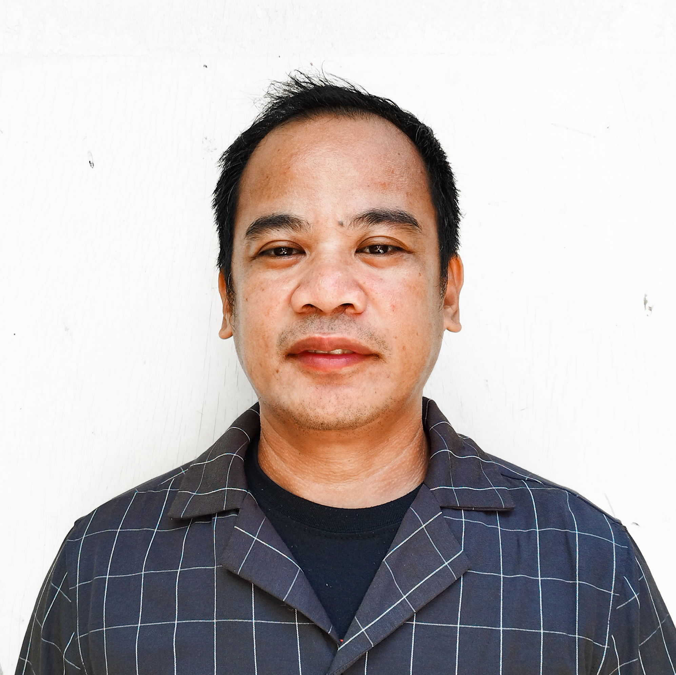

**Most Outstanding Employee**

This employee is proactive, a great leader, dependable, diligent, and reliable. They possess qualities that are unique and hard to find, but easily definable.

Alright, to receive a Certificate and 43 Inch Flat Screen TV. You are the chosen Outstanding Employee of The Year! Congratulations to?